The INTELLI-gent PLAC-ard Choice for Warehouse Labeling
“Distribution warehouse will use latest Technologies” *
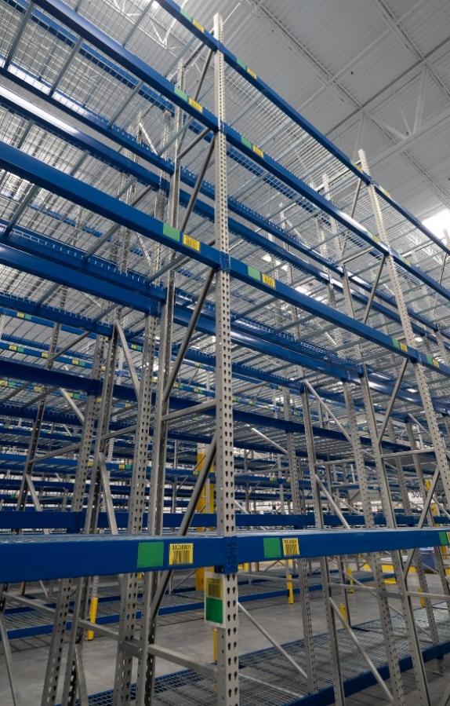
A new warehouse was built in Louisville, KY by a large multi-national corporation that has used INTELLI-PLAC® placards in other warehouses for the last 5 years. They went full out with this new 260,000 square foot parts distribution center. With 45,000 SKU’s and 60,000 bin/rack locations utilization of space is a priority. This is a non-specific location warehouse where bins are filled and emptied as needed. Products are not assigned to a certain bin or rack location.
Green INTELLI-PLAC® placard label holders mark the locations on racks and bins that will hold product identification labels which are printed by order pickers with mobile scanner/printers. Labels are frequently changed at these locations. INTELLI-PLAC® placards hold labels securely but allow them to be removed easily and release without leaving residue. The INTELLI-PLAC® surface is an embossed film with no silicone. The text and color print is locked in on the back side of the film by the adhesive. Permanent adhesive bonds the placards securely to painted steel, plastic, and cardboard surfaces. The result in this warehouse is a neat and orderly appearance and less chance for errors.
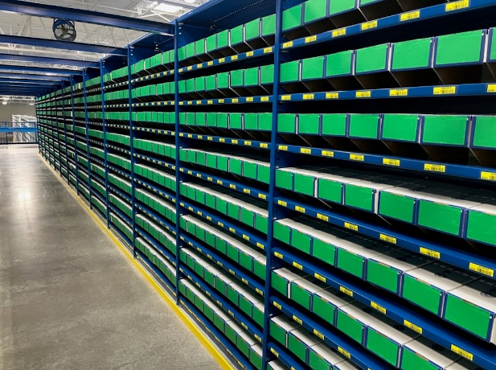

Mezzanine bins with green placards, blue shelf placards
Go for the Green – find an empty space

INTELLI-PLAC® GREEN placards size 3.5” x 5” were used on all bins and rack locations. Color coding using green is to show if a space is empty. When filled the green placard has a white product label applied so it is now WHITE. Operators GO for the GREEN space to place stock by using empty locations. Shelves have blue INTELLI-PLAC® in strips or die cut shape installed from 1” to 4” wide that hold the yellow location barcode info label. A custom blue to match the rack color was used.
Applying INTELLI-PLAC placards can be done with in-house employees as was done in this warehouse because the placards are easy to apply. They are sturdy, not flimsy. INTELLI-PLAC® placards are about 10 mils thick so the placard keeps its shape while being applied and does not fold over on itself. Templates were used for exact placement on racking.
A Simple Labeling Solution that is the Intelligent choice using INTELLI-PLAC® placards. July 13, 2022

For more information go to
www.filmloc.com
*As per press release May 2021.

