PACCAR Parts’ New Louisville KY Distribution Center
Using INTELLI-PLAC® placards
The INTELLI-gent PLAC-ard Choice
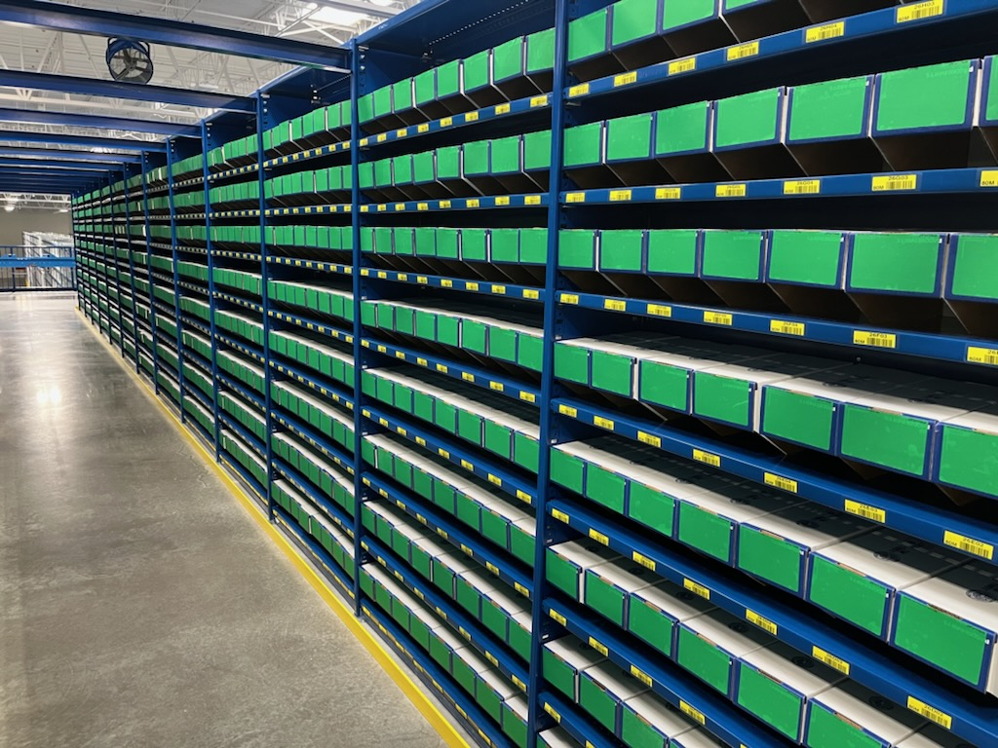
This shows the mezzanine floor with bin boxes ready for use. Cardboard bins are used for small parts storage. This warehouse has 45,000 SKU’s and moves 10 truckloads of parts per day. Each bin box has an INTELLI-PLAC® placard that will hold a product label.

This is a non-specific location warehouse where parts are stored according to open spaces as opposed to an assigned location/bin. This allows for optimum utilization of space as there will not be empty bins or bins that are over filled due to fixed locations.

According to their May 2021 press release, this warehouse uses the latest technologies including cutting edge software for managing inventory. INTELLI-PLAC® placards are everywhere in this warehouse making their Go for the Green Protocol work.

Incoming inventory is directed to an area of this 260,000 square foot warehouse based on the type of product. This can include palletized or individual parts. Based on the size of the part or pallet, inventory is then directed to aisles that have bins or spaces of the right size. Assigning parts to an area is determined by size, height, and frequency of use. Lower bins are utilized for more frequently turned items.
All bins have green placards that will hold a white inventory label when filled.
So when the bins are empty, they are green. Operators go to the green placard to put in new stock. A mobile printer /scanner is used to scan the yellow bar code label on the blue shelf holding the bin box. A label is printed and applied to the green placard. This will remain labeled showing white as long as stock is in the bin. When emptied the label is removed and it is now “green” and ready to be filled again.

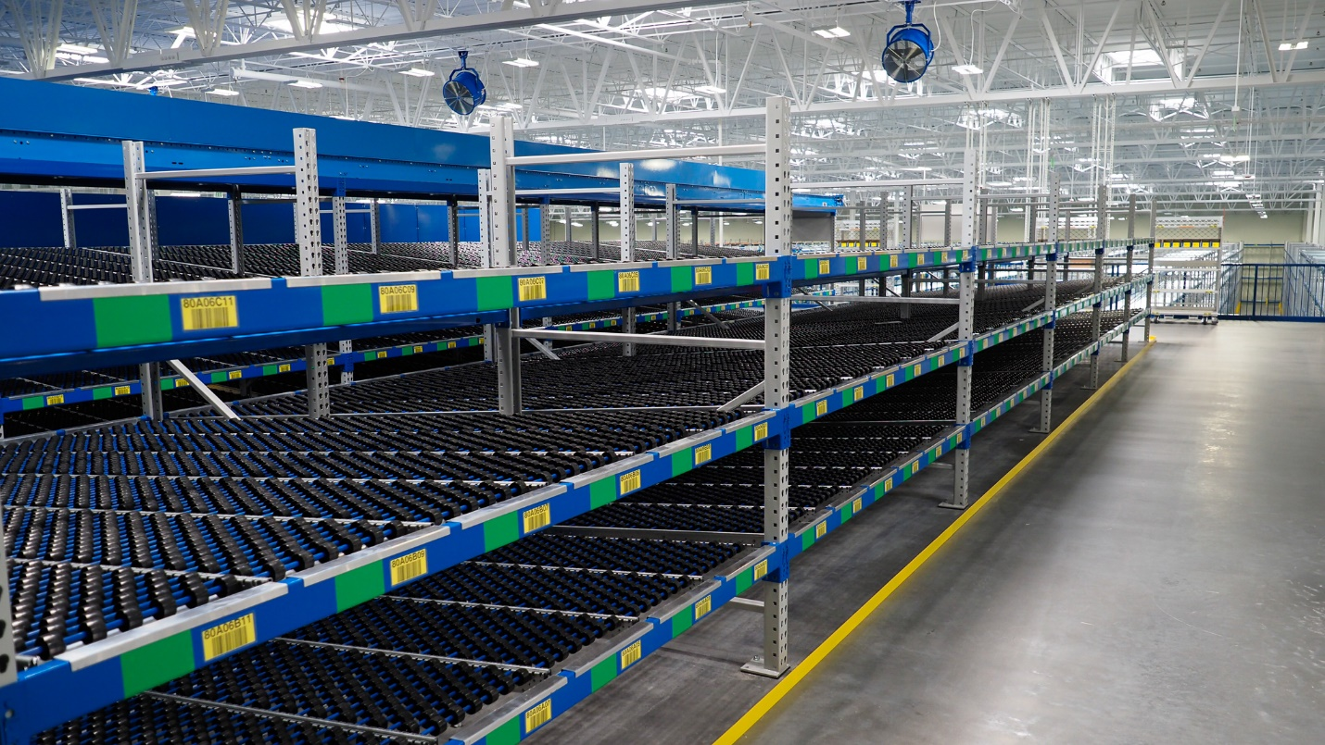
Mezzanine floor with flow racks. Green placards will have a ID printed label when filled and then can be changed.
The blue beams have matching blue INTELLI-PLAC placards that hold the yellow barcode location labels.

Durable embossed surface holds labels securely but can be removed easily without leaving residue. Cleaning can be done if dirt or dust or spills get on the placards. Cleaning agents such as detergents, alcohol or acetone can be used. Permanent adhesive is used on INTELLI-PLAC®PLACARDS. That allows the placards to adhere securely to cardboard, plastic and painted metal surfaces. On plastic and painted surfaces placards can be repositioned if not applied straight and then reapplied. Bonding takes 24 – 48 hours.

Applying INTELLI-PLAC® placards can be done with in house employees. Standard INTELLI-PLAC® placards’ film and adhesive are about 10 mils thick. This allows for stiffness, so the placard keeps its shape while being applied and is not flimsy and does not fold over onto itself. Placards are supplied on rolls die cut to shape or long strips to put on the front of shelves or racking. In this warehouse, templates were used to mark the placard location on shelves and racking, so all locations are exact. This makes for a neat and organized warehouse. INTELLI-PLAC® placards are durable as evidenced by repeated use in other PACCAR Parts distribution warehouses over the last 5 years with no failures.

PACCAR Parts Go for the Green protocol includes computers, printers, people, labels and INTELLI-PLAC®PLACARDS all working together so this distribution center can perform. According to a press release from May 2021 announcing the building of this center. “We are dedicated to providing customers with the highest level of product availability, quality service and unmatched value in the industry.”

FilmLOC Inc
filmloc.com
404.892.8778

